CSC-202L Artificial Intelligence Lab

Cyber Risk & Threat Intelligence System



Submitted By:

Afaaq Anwar | 2024-CS-603
Taimoor Ali | 2024-CS-609
Muhammad Arslan | 2024-CS-632
Ahsan Shakeel | 2024-CS-638

Submitted To:
Ms. Sonia Asghar

Department of Computer Science
University of Engineering and Technology Lahore, New Campus

Table of Contents
1. Abstract 3
2. Introduction 3
3. Problem Statement 3
4. Background 4
5. Methodology 4
5.1.1 Development Tools 4
5.1.2 Dataset 4
6. Algorithm Explanation 5
6.1. Step 1: Data Collection 5
6.2. Step 2: Feature Extraction 5
6.3. Step 3: Data Preprocessing 5
6.4. Step 4: Model Training 5
6.4.1 KNN Algorithm 5
6.5. Step 5: Threat Classification 5
6.6. Step 6: Rule-Based Reasoning 6
6.7. Step 7: Secure Storage 6
6.8. Step 8: Report Generation 6
7. Results and Screenshots 6
7.1.1 Screenshot 1: Landing Page 6
7.1.2 Screenshot 2: Dashboard Interface 7
7.1.3 Screenshot 3: PCAP File Upload 7
7.1.4 Screenshot 4: Threat Detection Result 8
7.1.5 Screenshot 5: Threat Logs 8
7.1.6 Screenshot 6: Generated Incident Report 8
7.1.7 Sample Results 9
8. Evaluation 9
8.1.1 Evaluation Metrics 9
8.1.2 Observations 9
9. Ethical Considerations 10
10. Limitations 10
11. Conclusion 10
12. References 10

Abstract
Cybersecurity threats are increasing rapidly due to the widespread use of networked systems and internet-based services. Traditional security monitoring approaches often struggle to identify sophisticated attacks in real time. This project presents a Cyber Risk & Threat Intelligence System that combines Machine Learning (ML), rule-based reasoning using Prolog, packet analysis, encrypted threat storage, and automated incident reporting. The system analyzes network traffic from PCAP files, extracts packet features, detects suspicious activities, classifies threats using a trained machine learning model, and stores incident records securely using AES-256-GCM encryption. A web-based dashboard provides real-time monitoring and visualization of detected threats. The proposed solution improves threat detection, incident management, and security intelligence while maintaining confidentiality and integrity of sensitive security logs.

Introduction
The increasing dependence on digital infrastructure has led to a rise in cyberattacks such as intrusion attempts, malware infections, network scans, SQL injection attacks, and denial-of-service attacks. Organizations require intelligent systems capable of monitoring network traffic and identifying malicious activities automatically.
This project develops a Cyber Risk & Threat Intelligence System that integrates Artificial Intelligence techniques with cybersecurity principles. The system captures and analyzes network traffic, applies machine learning models for anomaly detection, uses Prolog-based reasoning for threat diagnosis, securely stores incident information using encryption, and generates incident reports for security analysts.
The project demonstrates how AI can be applied in practical cybersecurity environments to improve threat detection and response capabilities.

Problem Statement
Modern networks generate a large volume of traffic, making manual monitoring difficult and inefficient. Security analysts often face challenges in:
- Detecting malicious traffic in real time.
- Identifying suspicious network behavior.
- Managing large amounts of security logs securely.
- Generating incident reports efficiently.
- Combining automated detection with expert reasoning.
Therefore, there is a need for an intelligent threat intelligence system that can automatically analyze network traffic, detect cyber threats, classify risks, securely store evidence, and provide meaningful security insights.

Background
Several cybersecurity solutions use machine learning for intrusion detection and anomaly detection. Datasets such as NSL-KDD are commonly used for training classification models that distinguish between normal and malicious network activities.
Research shows that:
- Machine Learning improves intrusion detection accuracy.
- K-Nearest Neighbors (KNN) is effective for network traffic classification.
- Rule-based systems provide explainable threat diagnosis.
- AES-256 encryption is widely adopted for secure storage of sensitive information.
- Threat intelligence platforms help organizations respond to cyber incidents more efficiently.
This project combines these concepts into a single integrated platform.

Methodology
The system follows the workflow shown below:
- Upload or capture network traffic.
- Extract packet features.
- Perform machine learning classification.
- Apply rule-based threat reasoning.
- Calculate risk level.
- Encrypt and store threat logs.
- Generate incident reports.
- Display results on dashboard.

Development Tools
- Python
- Flask
- Scikit-learn
- PyShark
- SQLite
- SWI-Prolog
- Flask-SocketIO
- AES-256-GCM Encryption

Dataset
The system uses NSL-KDD based datasets:
- nsl_kdd_large.csv
- nsl_kdd_synthetic.csv
These datasets are used to train and evaluate the machine learning model.

Algorithm Explanation

Step 1: Data Collection
Network packets are obtained from:
- Uploaded PCAP files
- Live packet capture

Step 2: Feature Extraction
Important features extracted include:
- Source IP Address
- Destination IP Address
- Protocol Type
- Source Port
- Destination Port
- Packet Length
- Payload Information

Step 3: Data Preprocessing
- Missing values removed
- Categorical features encoded
- Features normalized using StandardScaler

Step 4: Model Training
The project primarily uses the K-Nearest Neighbors (KNN) algorithm.

KNN Algorithm
- Store training samples.
- Calculate distance between test sample and training samples.
- Select K nearest neighbors.
- Assign the most frequent class among neighbors.
K = 5 was used in the implementation.

Step 5: Threat Classification
The trained model predicts whether traffic is:
- Normal
- Malicious
- Anomalous

Step 6: Rule-Based Reasoning
Prolog knowledge base applies expert security rules to determine:
- Threat category
- Severity
- Recommended mitigation actions

Step 7: Secure Storage
Threat logs are encrypted using AES-256-GCM before storage in SQLite database.

Step 8: Report Generation
The system automatically generates incident reports for detected threats.

Results and Screenshots

Screenshot 1: Landing Page
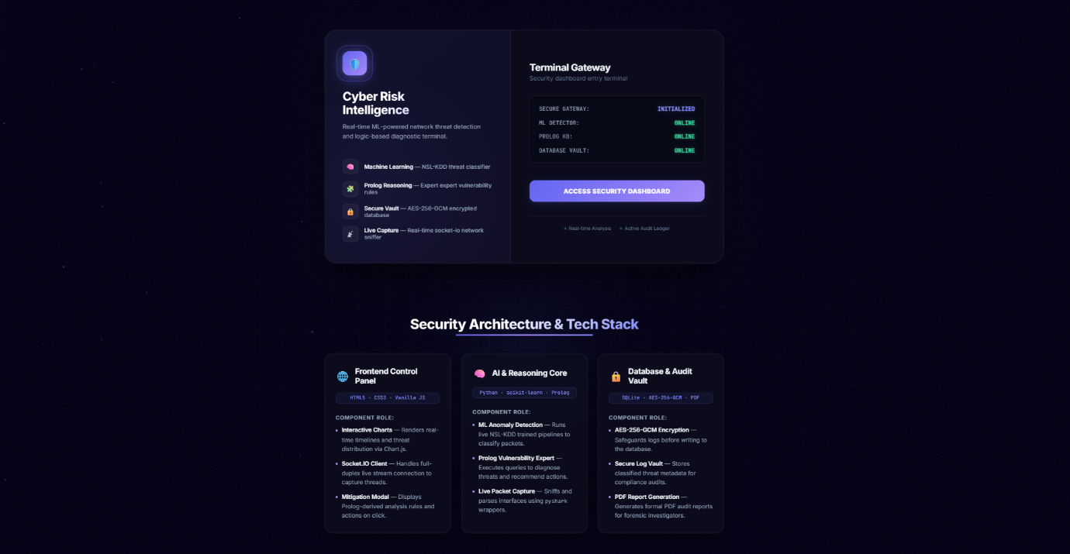
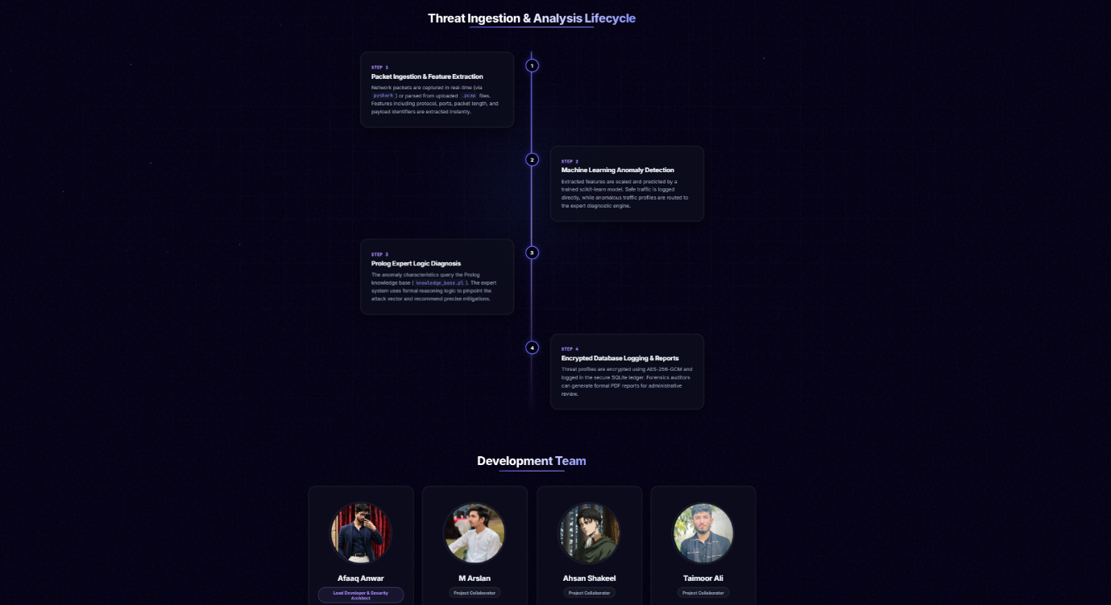

Screenshot 2: Dashboard Interface
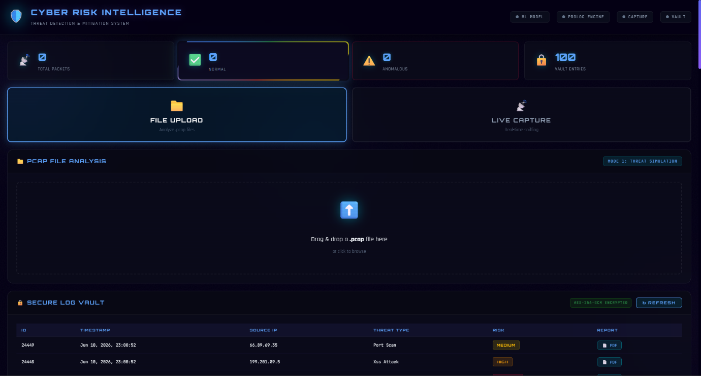

Screenshot 3: PCAP File Upload
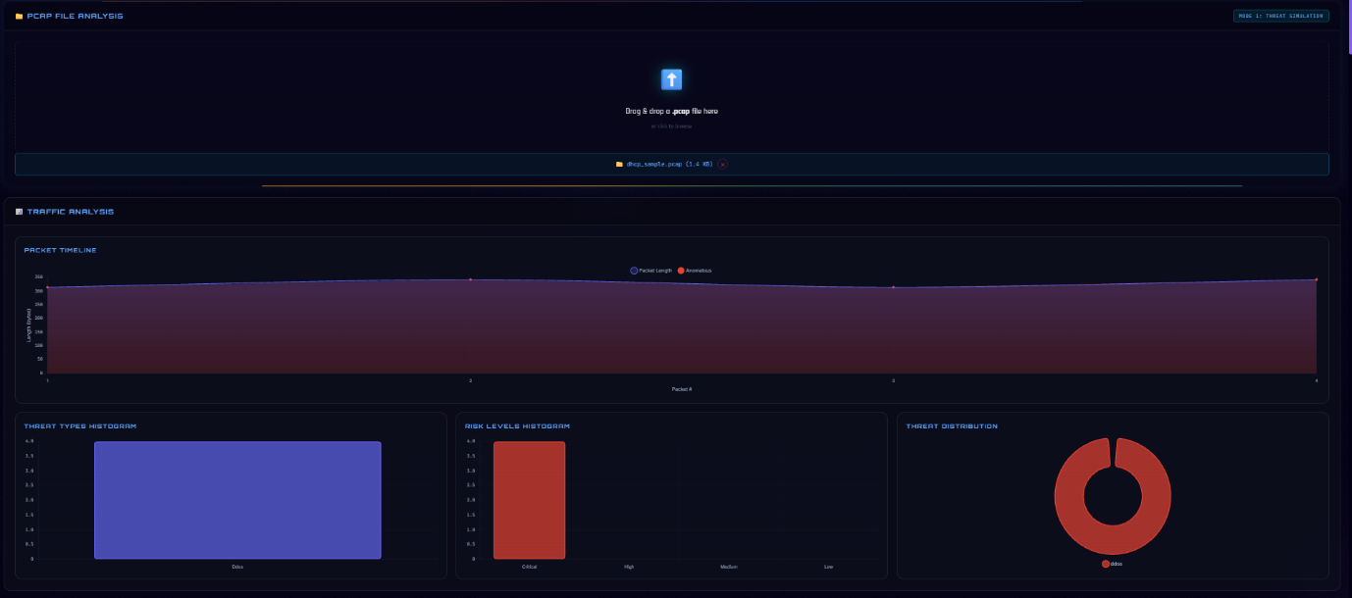

Screenshot 4: Threat Detection Result
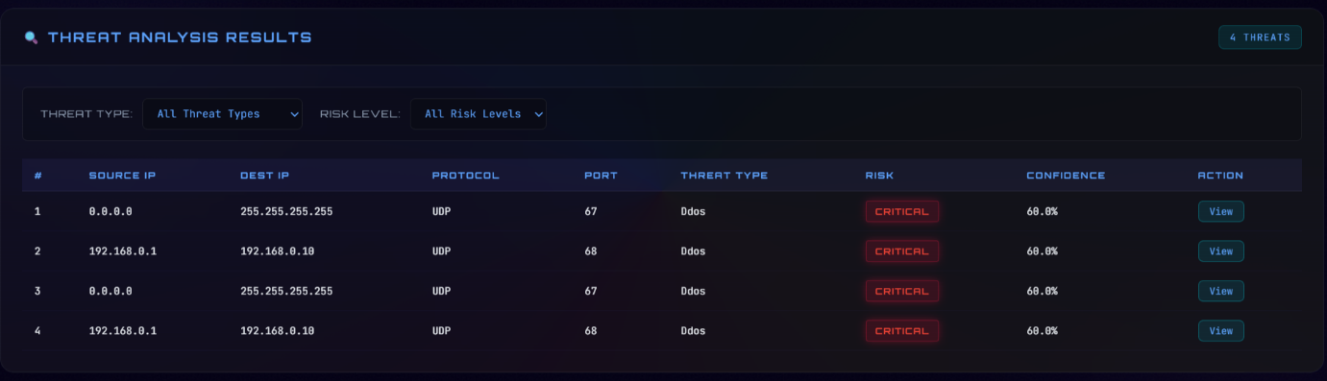

Screenshot 5: Threat Logs
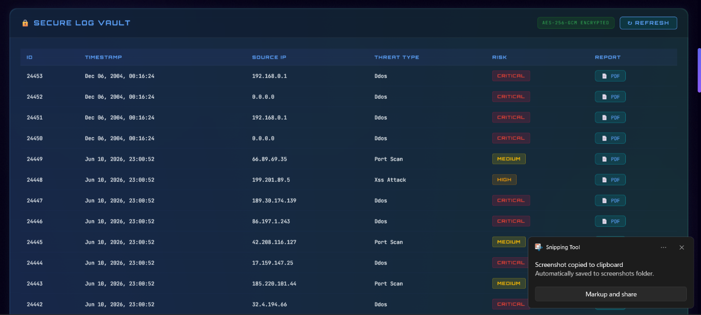

Screenshot 6: Generated Incident Report
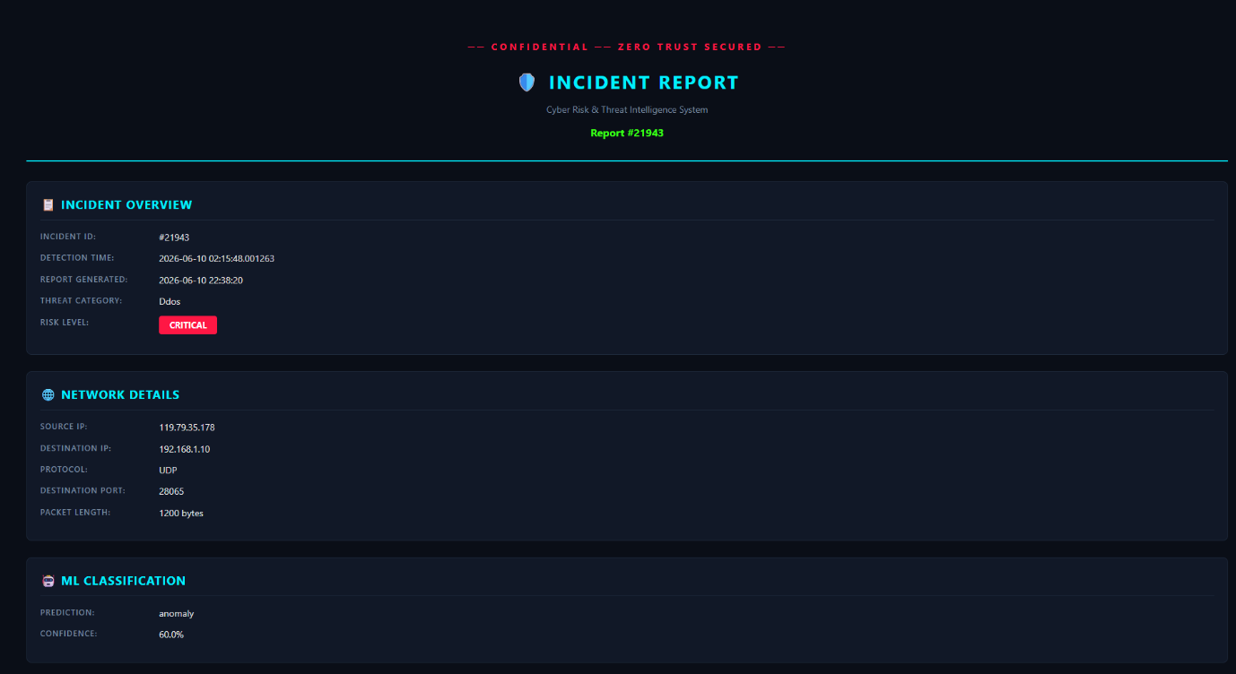

Sample Results
Parameter | Result
Dataset Used | NSL-KDD
Model | KNN
K Value | 5
Threat Detection | Successful
Report Generation | Successful
Secure Log Storage | Successful
Real-Time Monitoring | Supported

Evaluation
The system was evaluated based on functionality and performance.

Evaluation Metrics
- Threat Detection Accuracy
- Classification Reliability
- Encryption Security
- System Response Time
- Report Generation Capability

Observations
- Successfully classified network traffic.
- Detected suspicious packet patterns.
- Stored logs securely using AES encryption.
- Generated readable incident reports.
- Provided real-time dashboard monitoring.
The integrated approach improved both security monitoring and incident management.

Ethical Considerations
The project was developed with responsible cybersecurity practices.
- Used only educational and research datasets.
- No unauthorized network monitoring was performed.
- User privacy was protected.
- Threat logs were encrypted to maintain confidentiality.
- The system is intended for defensive cybersecurity purposes only.

Limitations
The current implementation has several limitations:
- Depends on the quality of training data.
- KNN performance may decrease with very large datasets.
- Limited threat categories compared to enterprise solutions.
- Prolog rules require manual updates for new attack types.
- Real-world deployment would require larger datasets and advanced models.

Conclusion
This project successfully developed an AI-powered Cyber Risk & Threat Intelligence System capable of detecting suspicious network activities, classifying threats using machine learning, applying rule-based reasoning, securely storing threat information, and generating incident reports. The integration of KNN classification, Prolog reasoning, AES-256 encryption, and Flask-based visualization demonstrates the practical application of Artificial Intelligence in cybersecurity. The system provides an effective foundation for intelligent network monitoring and cyber threat analysis.

References
- Tavallaee, M., Bagheri, E., Lu, W., & Ghorbani, A. A. (2009). A Detailed Analysis of the KDD CUP 99 Dataset and the NSL-KDD Dataset.
- Scikit-Learn Documentation. https://scikit-learn.org
- Flask Documentation. https://flask.palletsprojects.com
- PyShark Documentation. https://github.com/KimiNewt/pyshark
- SWI-Prolog Documentation. https://www.swi-prolog.org
- SQLite Documentation. https://www.sqlite.org
- NIST Cybersecurity Framework.
Stallings, W. Cryptography and Network Security: Principles and Prac

